1. Write a program to find the area of rectangle. Take input from user.
Eg. x= int(input(‘Enter number:’))
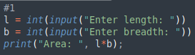
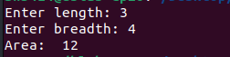

2. Write a program to swap the values of two variables
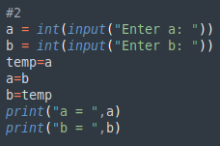
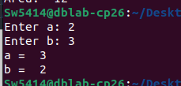

3. Write a program to find whether a number is even or odd
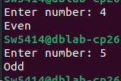
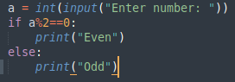

4. Write a program to check the largest among the given three numbers.
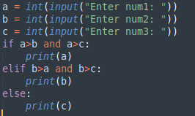
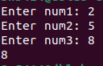

5. Write a program to demonstrate List functions and operations
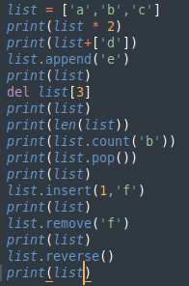
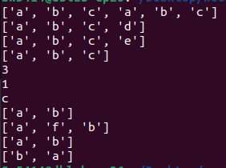

6. Consider the tuple(1,3,5,7,9,2,4,6,8,10). Write a program to print half its values in one line and
the other half in the next line.
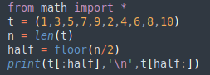
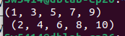

7. Consider the tuple (12, 7, 38, 56, 78 ). Write a program to print another tuple whose values are
even number in the given tuple.
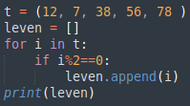

8. Write a Python program to print negative Numbers in a List using for loop. Eg. [11, −21, 0, 45,
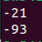
66, −93].
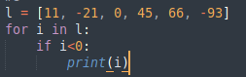

9. Write a Python program to count positive and negative numbers in a List.
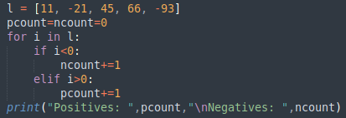
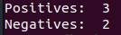

10. Write a Python program to remove all even elements from a list
